R. Reports Menu: 6. Inheritance Report

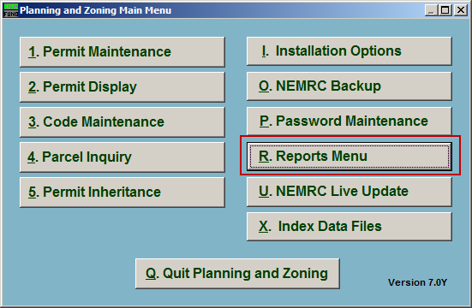
Click on “R. Reports Menu” from the Main Menu and the following window will appear:

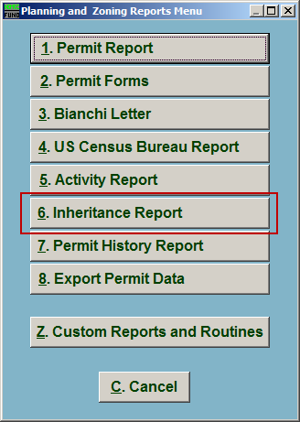
Click on “6. Inheritance Report” from the Reports Menu and the following window will appear:

Inheritance Report

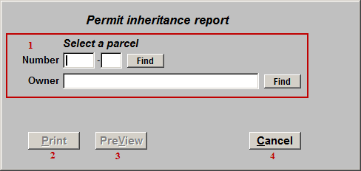
- Select a parcel: Locate the Parcel that this report is for.

- Print: Click this button to print. Refer to GENERAL PRINTING for more information.

- PreView: Click this button to preview. Refer to GENERAL PREVIEW for more information.

- Cancel: Click “Cancel” to cancel and return to the Reports Menu.

